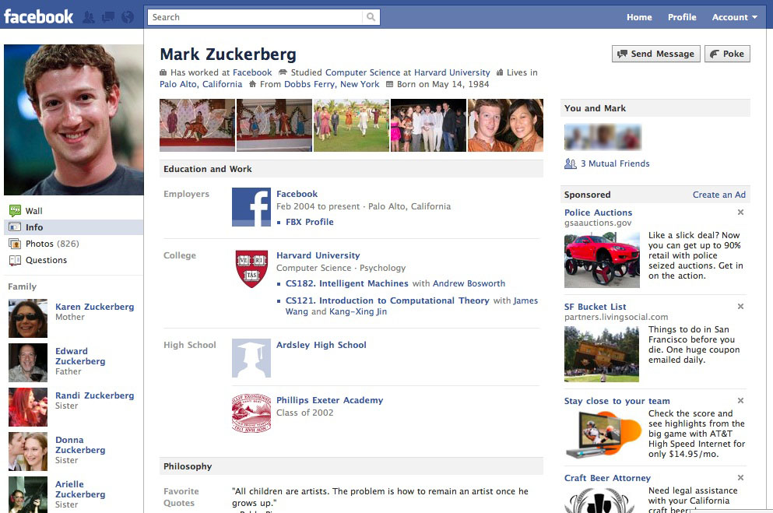C:\Users\Jason\AppData\Local\Microsoft\Windows\Temporary Internet Files\Content.IE5\KY24S6JA\MC900434804[1].pnghttp://cdn4.iconfinder.com/data/icons/cc_mono_icon_set/blacks/48x48/pencil.pnghttp://cdn4.iconfinder.com/data/icons/cc_mono_icon_set/blacks/48x48/pencil.pnghttp://cdn4.iconfinder.com/data/icons/cc_mono_icon_set/blacks/48x48/pencil.png

Name of

Movie

Name of

Movie

Name of

Movie

Name of

Movie

Name of

Group

Name of

Group

Name of

Group

Name of

Group

Name of

Person

Name of

Person

Name of

Person

Name of

Person

Name of

Person

Name of

Show

Name of

Show

Name of

Show

Name of

Show

Friends ( )

Friends

Subscriptions

Info

Wall

Photos

Notes

High School

Born on (fill in date)

**Type your name here**

* Type
* Information
* Here

Games, Sports,

Hobbies, etc.

**Activities and Interests** Edit

Television

Movies

Music

Type name of business here

Position • Month Year to present • Location

Type name of high school here

Class of (fill in year)

Employer

**Arts and Entertainment** Edit

**Work and Education** Edit